**INNOVATION ON BUILDING A SMARTER AI POWERED SPAM CLASSIFIER.**

**Problem:**

Explain in detail about the complete steps will be taken to put your design on innovation on building a smarter AI powered spam classifier.

**Solution:**

**Spam classifier:**

A spam classifier is a software or algorithm designed to automatically categorize incoming messages or content as either “spam” or “ham”

The parameters are:

Data Collection:

The classifier is trained on a dataset containing a large number of examples of both spam and non-spam messages.

Feature Extraction:

Features or attributes are extracted from the messages. these features can include words, phases, sender information etc.

Training:

Using the labelled dataset, the classifier learns to recognize patterns and relationships between the features and spam categories. Common machine learning algorithms like Naïve Bayes, Support Vector Machines etc., can be used.

 **SPAM CLASSIFIER USING AI:**

Creating a spam classifier using AI typically involves machine learning techniques.

1.Data Collection:

Gather a dataset of emails or messages, categorizing them as either spam or non-spam. This dataset will be used to train and test your classifier.

2.Data Preprocessing:

Clean and preprocess the text data. This may involve tasks like removing special characters, lower casting, tokenization and stemming or lemmatization.

3.Feature Extraction:

Convert the text data into numerical features that machine learning models can be understand. Common techniques include TF-IDF or word embeddings can be used.



4.Model selection:

Choose a machine learning algorithm to train on your dataset.

Common choices include SVM and Recurrent Neural Networks.

5.Training:

Split your dataset into a training set and a validation set. Train your chosen model on the training data, adjusting hyperparameters as needed.

6.Evaluation:

Evaluate the model’s performance on a separate test dataset using metrices like accuracy, precision, recall and F1 score.

7.Deployment:

Once satisfied with the model’s performance, deploy it in your application or email system to automatically classify incoming messages or not.

8.Continuous improvement:

Spam patterns change over time, so it is essential to monitor and update your classifier.

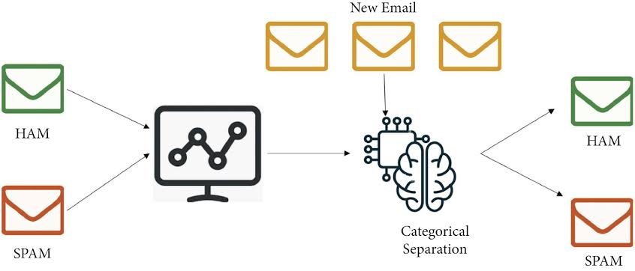

**Innovation of building a smarter AI powered spam classifier:**

To innovate building a smarter AI powered spam classifier requires a combination of advanced techniques and data driven approaches.

1.Collect Diverse Data:

Gather a diverse and extensive dataset of spam and non-spam messages. This should include different languages, formats and sources to improve the classifier’s robustness.

2.Feature Engineering:

Extract relevant features from the text such as word frequency, n-grams, sender information, and email structure.



3.Machine Learning Algorithms:

Experiment with various machine learning algorithms such as SVM, Random forests to optimize performance.

4.Ensemble Methods:

Combine multiple models using ensemble techniques like bagging, boosting or stacking to improve classification accuracy and reduce over fitting.

5.Anomoly Detection:

Implement anomaly detection techniques to identify unusual patterns in email content.

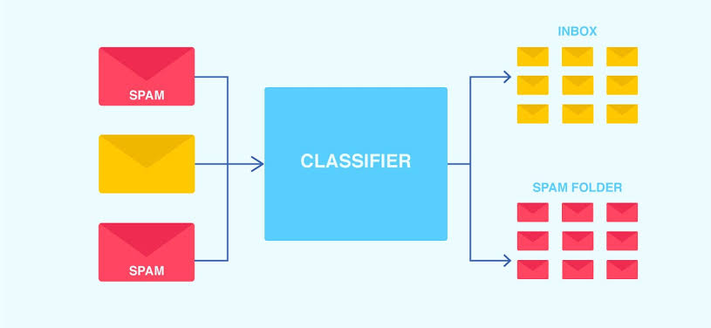

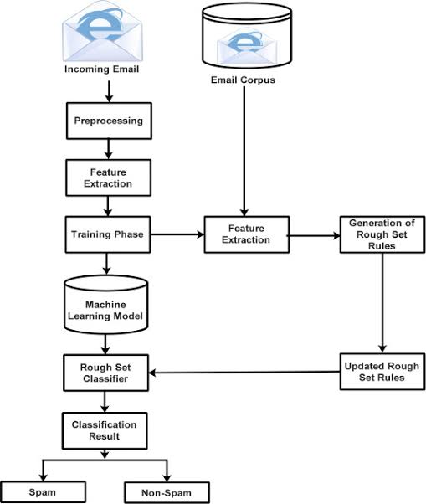

**CONCLUSION:**



By accurately identifying and filtering spam, individuals and organizations can focus on important emails and mitigate potential risks associated with malicious content. In conclusion, email spam detection using machine learning offers a promising solution to the pervasive problem of unwanted and harmful emails.